Voronoi-based Indoor Room Search And Rescue With Environmental Exploration
Meshaal. Mouawad
Department of Electrical and Computer Engineering, Mississippi State University
This technical report is to process of my research during the Summer, 2021.
Technical Report
Abstract—In this project, we investigate of autonomous robots for mapping, navigation, with the shortest path planning to the
target. We implemented Voronoi Diagram for path planning such as the Global Path and avoiding the obstacles, we generated local targets (multiway-points) and applied Travel Salesman Problem (TSP) Algorithms to find the optimal path (shortest path planning) to connect the waypoints by searching the closest edge of the Voronoi diagram, we then applied the Dynamic Window Approach method (DWA) to allow the robot to navigate locally based on the TSP and Voronoi diagram paths. The robot was given an assignment to navigate from the start point (source) to the end point with local targets (targets). Then the robot has to complete the assignment as the followings from the start point find the shortest path, go to the local targets (the targets), with avoiding the obstacles.

Index Terms:

PROJECT OUTLINE
S
EARCH and rescue is the final goal of this research project. Assume we have a disaster, and we want to search people whom were injured inside a building and we want the robot to navigate and search inside the rooms. To do this we need to find the path planning, determine the targets, find the optimal path for the target with shortest distant, then navigate locally to the targets. This can be categorized as four stages as the followings: Environmental Exploration, Multi-Goal Path Planning, Local Navigator, and 2D Grid Mapping.

In the Environmental Exploration stage, we constructed two
kinds of Voronoi Diagram maps: Voronoi Diagram, and
Generalized Voronoi Diagram (GVD) as follows as it shows in fig. 1. and fig. 2.

In the Multi-goal path planning, we used the Voronoi Diagram (GVD) maps with for TSP (Travelling salesman problem) algorithms to connect some goals/waypoints that we need to explore, rescue, and reach. Running your TSP algorithm to connect some points such as the green circles $P_{n}$ in Fig. 3. TSP can connect waypoints,$P_{1}, P_{2}, P_{3}…P_{n}$ (injured persons – we have known their GPS coordinates such as the local targets in Table. 1) in certain sequence to minimize the total traveling distance. The result would be the optimal path, the green path in Fig. 3, for the targets (local targets).

Fig. 1. Generalized Voronoi Diagram (GVD

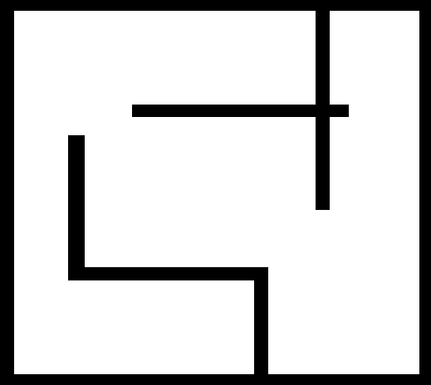
Fig. 4. The original map we used in the project.

TABLE I
The Local targets for TSP
Local locations | Local targets  $$P_{n}$$ | X Y
0 | $$P_{1}$$ | 420 450
1 | $$P_{2}$$ | 220 220
2 | $$P_{3}$$ | 200 40
3 | $$P_{4}$$ | 150 430
4 | $$P_{5}$$ | 40 250
5 | $$P_{6}$$ | 450 300

TSP local targets as we chose for the targets

The red points are the map nodes given by Voronoi diagram where node 1 is the starting node and node 25 is the ending node.

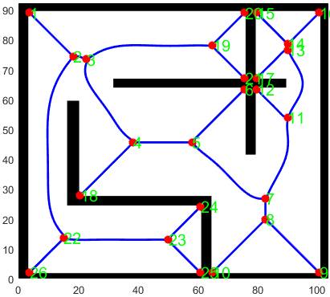
Fig. 2. Voronoi Diagram with the path planning

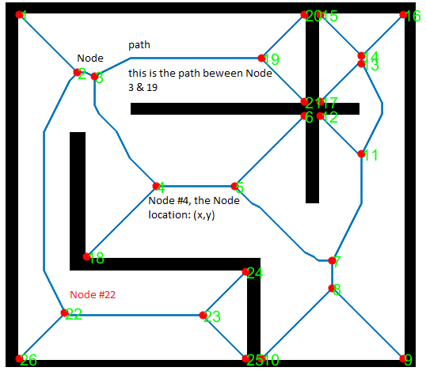
Fig. 6. The Voronoi Diagram specifications

Fig. 3 the expected optimal path using TSP (Travelling salesman problem) algorithms. the blue line is the path planning for the Voronoi Diagram, the green path is the optimal path for the targets (local targets), and the green circles are the targets.
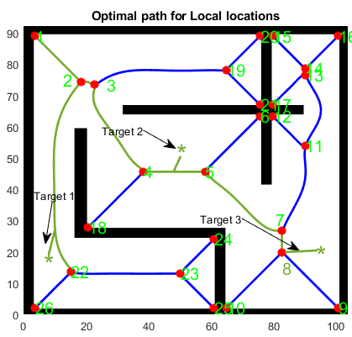

Once sequence has been determined, robot needs to carry out path planning (navigation).
• Robot will perform navigation/path planning.
• Build up map (Mapping).

The local navigator we implemented in this project is the DWA (Dynamic Window Approach) method to walk a mobile robot from starting point, the red point number 1, to goal, the $P_{n}$ green points, along the edges of built GVD, the blue path. This task significantly to using DWA to navigate the robot to
connect multiple goals depicted by the green points such that the green path in Fig. 3.

The Project Stages

Environmental Exploration
We constructed the Voronoi Diagram using the map in Fig. 4. The map black lines are the walls (obstacles). The robot can only move in the empty area in the map and avoid any obstacles such as the walls. To find the global path, we used the Voronoi Diagram method as it shows in Fig. 2. In this stage we must specified the robot radius, the obstacles, the board. The radius of the robot, is used to compute configuration free space as it shows in Fig. 5. in case if the robot's radius is big, the path in the graph will be disconnected which means it can not pass through a narrow corridor or door in the map due to the collision’s expectations.

Fig. 5. The free space of the map in Voronoi diagram.

Multi-goal path planning
We chose local targets $P_{n}$ such as the points in Table.1 as a target similar to those in Fig. 3 by choosing its locations on the generated Voronoi diagram and adding its coordinates to the map. This stage we calculated the path length using equation. then, we find the cost matrix.

Where P is the path between the nodes
Then we combined all points in a map with the targets to find the optimal path to the local targets using TSP. We formulated TSP algorithms by an integer linear programming and solved it by the Miller–Tucker–Zemlin (MTZ) formulation [2]. For time optimization, we used CBC MILP Solver as a solver for TSP.

Using the local targets in Table. 1, the start point is $P_{1}$ = (420,450). Then the optimal path to navigate those local targets is the sequence [(0, 3), (1, 5), (2, 1), (3, 4), (4, 2), (5, 0)]

where 0, 1, … 5, is the local targets in Table. 1.

Local navigator
DWA method will breakdown the optimal path, the green path specifically between waypoints, to multiple points that DWA can navigate locally.

Here is the last result where the robot will navigate to the local targets and achieve the goal. We try to search the closest edge of the Voronoi diagram.

Mapping

Local navigator
DWA method will breakdown the optimal path, the green path specifically between waypoints, to multiple points that DWA can navigate locally.

Here is the last result where the robot will navigate to the local targets and achieve the goal. We try to search the closest edge of the Voronoi diagram.

Multi-goal Path Planning

Traveling Salesman Problem
The Traveling Salesman Problem (TSP) is one of the most famous combinatorial optimization problems. This problem is very easy to explain, but very complicated to solve – even for instances with a small number of cities. More detailed information on the TSP can be found in the book The Traveling Salesman Problem: A Computational Study [1], or at the TSP home page [2]. If you are interested in the history and mathematical background of the TSP, we recommend that you watch the video by William Cook [3].

The origin of the traveling salesman problem is not very clear; it is mentioned in an 1832 manual for traveling salesman, which included example tours of 45 German cities but was not formulated as a mathematical problem. However, in the 1800s, mathematicians William Rowan Hamilton and Thomas Kirkman devised mathematical formulations of the problem.
It seems that the general form of the Traveling Salesman Problem was first studied by Karl Menger in Vienna and Harvard in the 1930s.
The problem became more and more popular in the 1950s and 1960s. In particular, George Dantzig, D. Ray Fulkerson, and Selmer M. Johnson at the RAND Corporation solved the 48-state problem by formulating it as a linear programming problem. The methods they described in their paper on this topic set the foundation for future work in combinatorial optimization, especially highlighting the importance of cutting planes.
References
[1] D. L. Applegate, R. E. Bixby, V. Chvatal and W. J. Cook , The Traveling Salesman Problem: A Computational Study, Princeton University Press, Princeton, 2006.
[2] http://www.math.uwaterloo.ca/tsp/index.html
[3] https://www.youtube.com/watch?v=q8nQTNvCrjE&t=35s
[4] http://www.math.uwaterloo.ca/tsp/concorde.html

Polynomial Time Vs. Nondeterministic Polynomial Time

The P vs. NP problem is the most notorious unsolved problem in computer science. First introduced in 1971, it asks whether one class of problems (NP) is more difficult than another class (P).
Mathematicians group problems into classes based on how long they take to be solved and verified. "NP" is the class of problems whose answer can be verified in a reasonable amount of time. Some NP problems can also be solved quickly. Those problems are said to be in "P", which stands for polynomial time. However, there are other problems in NP which have never been solved in polynomial time.
The question is, is it possible to solve all NP problems as quickly as P problems? To date, no one knows for sure. Some NP questions seem harder than P questions, but they may not be.
Currently, many NP problems take a long time to solve. As such, certain problems like logistics scheduling and protein structure prediction are very difficult. Likewise, many cryptosystems, which are used to secure the world's data, rely on the assumption that they cannot be solved in polynomial time.
If someone were to show that NP problems were not difficult—that P and NP problems were the same—it would would have significant practical consequences. Advances in bioinformatics and theoretical chemistry could be made. Much of modern cryptography would be rendered inert. Financial systems would be exposed, leaving the entire Western economy vulnerable.
Proving that P = NP would have enormous ramifications that would be equally enlightening, devastating, and valuable...
TSP Movie (cite)

- Problem Description
The TSP can be defined as follows: for a given room map with list of nodes, nodes are the global path from the Voronoi Diagram, and the distances between each pair of them, we want to find the optimal path planning, the shortest possible route, that goes to each object in the room once and returns to the start point, first object in another word the first node.
.
There is a class of Traveling Salesman Problems that assumes that the distance of going from node ii to node jj is the same as going form node jj to node ii, this type of Traveling Salesman Problem is also known as the symmetric Traveling Salesman Problem. In this example, we use Euclidean distances, but the TSP model formulation is valid independent of the way in which the individual distances are determined.

- Solution Approach
Mathematical programming is a declarative approach where the modeler formulates a mathematical optimization model that captures the key aspects of a complex decision problem. The Gurobi Optimizer solves such models using state-of-the-art mathematics and computer science.
A mathematical optimization model has five components, namely:
- Sets and indices.
- Parameters.
- Decision variables.
- Objective function(s).
- Constraints.

We now present a MIP formulation of the TSP that identifies the shortest route that goes to all the nodes once and returns to the origin node

- TSP Model Formulation

The basic model for Traveling Salesman Problem TSP is as follows:
- Sets and Indices
i,j ∈ local targets: indices and set of map local targets.
Pairings = {(i,j) local targets × local targets}: Set of allowed pairings.
S ⊂ local targets: A subset of the set of local targets.
G = (local targets, Pairings): A graph where the set local targets define the set of nodes, and the set Pairings defines the set of edges.

- Parameters
$d_{ij}$ ∈ $R^{+}$: Distance from local target $ii$to local target $jj$, for all $(i,j)$ ∈ Pairings $(i,j)$ ∈ Pairings. Note that $d_{ij}=d_{ji}$ which is symmetric.

- Decision Variables
$x_{ij}∈\{0,1\}$: it is equal to 1, if we decide to connect local target i with local target j, it has a direct path from node i to j, Otherwise, the decision variable is equal to zero.

- Objective Function
Shortest Route. Minimize the total distance of a route. A route is a sequence of local targets where the robot visits each target only once and returns to the starting point, the 1st local target.
- Constraints
- Symmetry Constraints. For each edge $(i,j)$, ensure that the local targets ii and jj are connected, if the former is visited immediately before or after visiting the latter.
- Entering and leaving a local target. For each local target ii, ensure that this local target is connected to two other local targets.

∑(i,j)∈Pairingsxi,j=2∀i∈Capitals(2)

- Input the data and problem visualization
Table.1, contains the local targets in the map of Figure. 3 with their x and y coordinate. The start point [420, 450] is assumed to be the starting point of the robot trip. The data input to TSP model is the distance matrix which stores the distance (or cost) from each location to every other location. Thus, for a traveling salesman problem for N target locations, the distance matrix is of size N x N. The variable no_of_locs in the code is used to define the first n no. of target locations we want to include in our TSP problem data which is 6 for our map.
The LP model is formulated as follows

Where:
N is the number of local location (the targets) including the starting point.
$C_{ij}$is the edge cost from node i to node j where i,j = [1…N].
$Y_{ij}$ is 1 if solution has direct path from node i to j, otherwise 0.

The objective function in Equation is to minimize the total distance and $C_{ij}$ is the distance or weight of arc (i,j), Equations and are the assignment constraint, which ensures that each node is visited and left exactly once for the targets specified in Table.1, and Equation indicate that $Y_{ij}$ is a binary variable and equals to 1 if arc (i,j) participates in the tours, 1 if solution has direct path from node i to j otherwise, 0.

The basic model that is mentioned above is not complete because it does not support the Hamiltonian circuit. Suppose there are six nodes and a traveler wants to visit all of them, he can do this in the two ways shown in Figure

Then we combined all points in a map with the targets to find the optimal path to the local targets using TSP. We formulated TSP algorithms by an integer linear programming and solved it by the Miller–Tucker–Zemlin (MTZ) formulation [2]. For time optimization, we used CBC MILP Solver as a solver for TSP.

Using the local targets in Table. 1, the start point is $P_{1}$ = (420,450). Then the optimal path to navigate those local targets is the sequence:
[(0, 3), (1, 5), (2, 1), (3, 4), (4, 2), (5, 0)]

Conclusion

References

Appendix. I

Voronoi-based Indoor Room Search and Rescue with Environmental Exploration

In the map, we first randomly generate 5 targets (yellow circles) and set the robot start point (blue square). The coordinates of the startpoint and targets are shwon below.
startpoint = [420,450];
targets = [220, 220;
200,40;
150,430;
40,250;
450,300 ];
Fig. x. Appendex. 1

The distance matrix of the startpoint and the targets can be denoted as
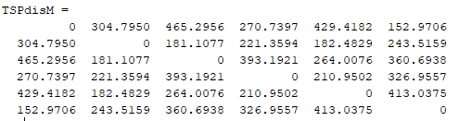
Use this distance matrix to the MTZ TSP code.
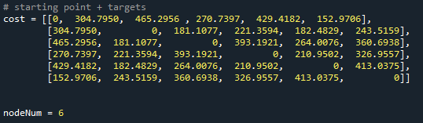
Get the route sequence result as [0,5,1,2,4,3,6].
Starting point Target NO. 5 Target NO. 1 Target NO. 2 Target NO. 4 Target NO. 3

For DWA the goal should be
Node 8 Node 7 Target NO. 5 Node 5 Target NO. 1 Node 4 Node 3 Target NO. 2 Node 2 Target NO. 4 Node 22 Target NO. 3

Total 12 waypoints. Get the node coordinates from the VD code.
[413 99.0000000000000]
413 134.000000000000
450,300
290 228
220, 220
191 228
113 367
200,40
91.0000000000000 372
40,250
75 68.0000000000000
150,430

The original VD has 0.2 resolution but I have expand to the origianl map as 461*518.
Can rescale the map to different size.

Run main.m in Folder “3 DWA_voronoi Simulation 1”.
The DWA can operate the robot towards the above listed waypoints.
Since the map is large and I have not configure the parameter into a good performance, so please adjust the following parameters.

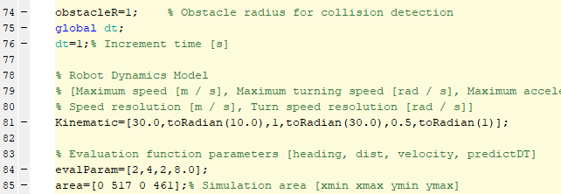
The above parameter can be adjusted.
All the waypoints have already load into the code.

Another Sample:
I have set another starting point as [20,20] and get following result.
startpoint = [20,20];
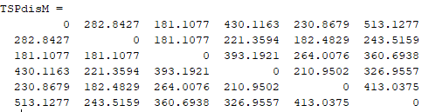
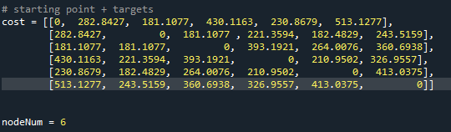

[Wednesday 5:09 PM] Lei, Tingjun
when you run the DWA code, you will find it is super slow, because I have used the original map which is like 400*500 matrix

But you need to be careful when you change the map size, because you need to adjust your waypoints coordinates as well

[Wednesday 5:15 PM] Lei, Tingjun
if you check the code in "4 VD DWA code 20210710\3 DWA_voronoi Simulation 1"
​
[Wednesday 5:16 PM] Lei, Tingjun
That's a shrinked map with 100*100.
​
[Wednesday 5:17 PM] Lei, Tingjun
However, that is not completely accurate. But sometimes there may be some tradeoffs, it's up to you.

Code Using Instructions
From VD, we have this kind of result, 36 nodes in the graph
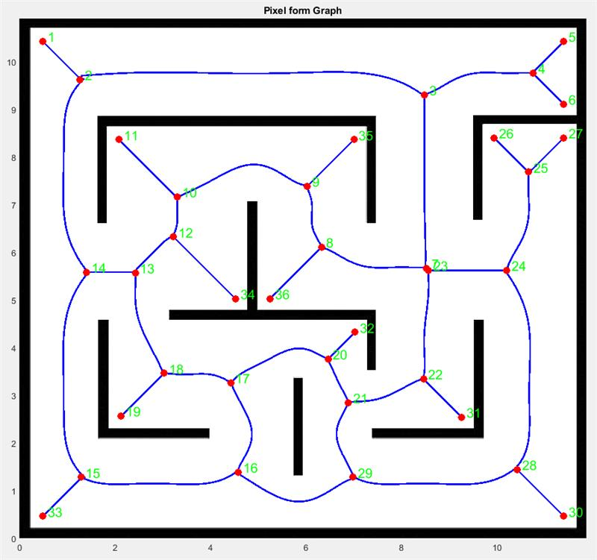

You first need to get the "Node distance matrix", which means the node to other nodes path length (not euclidean distance) .
​
The path can be found in your code from the variable "EdgeLabel" or "GRAPH"

For example, double click the "74*2 double", which means the path from node "1" to node"2". Then you will see the path x, y coordinate from node 1 to node 2

GRAPH: CONTAINS NODES AND PATH BETWEEN NODES(IN PIXEL)
from : the corresponding start node
to : the corresponding end node

QUADGRAPH: CONTAINS THE GRAPH IN THE FORM OF QUADRATIC FUNCTION FOR EACH EDGE
number_nodes: number of nodes in the constructed graph
node_list: location of the nodes
edge_matrix: Adjacency matrix of the graph
path_matrix: The Path between all the nodes
w_s : size of the work space
Pol_coefs: coefficent of the quadratic form of the edges

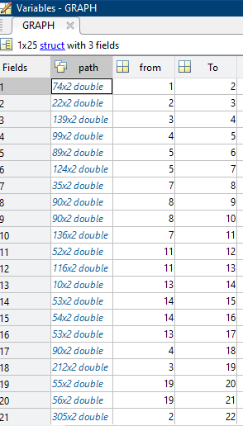

This contains the path and you need to calculate the distance by adding the length step by step.

pathstep = size(path,1);
pathlength = 0;
for i = 1: pathnode-1
temp = sqrt((path(i+1,1)-path(i,1))^2+(path(i+1,2)-path(i,2))^2);
pathlength = pathlength + temp;
end pathlength
​
The above is a sample to calculate the path length.

Table.2 The Node List
Node Number | X | Y
1 | 3.6 | 89
2 | 18.2 | 74.4
3 | 22.6 | 73.4
4 | 38.2 | 45.6
5 | 58 | 45.6
6 | 75.6 | 63.4
7 | 82.6 | 26.8
8 | 82.6 | 19.8
9 | 100.6 | 2
10 | 64.8 | 2
11 | 90 | 53.8
12 | 79.6 | 63.4
13 | 90 | 76.6
14 | 90 | 78.6
15 | 79.6 | 89
16 | 100.6 | 89
17 | 79.6 | 67
18 | 20.6 | 27.8
19 | 64.8 | 78
20 | 75.6 | 89
21 | 75.6 | 67
22 | 15 | 13.6
23 | 50 | 13
24 | 60.8 | 24
25 | 60.8 | 2
26 | 3.6 | 2
Table.2, contains the coordinalte (x,y) for each node in the voronoi diagram. It has 26 Nodes, with x & y locations. For example Node 1 location (3.6,89), Node 2 (18.2,74.4) … etc

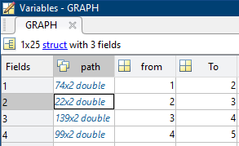

Here is the Path coordinate (x,y). from Node 1 to Node 2 the path between them has this location using Eq. 1. And GRAPH(1).path(1) which is in Fig. 8, For node 1 to node 2, the path (x,y) corrdinate start from (16,18), (17,19) …to the end at (89, 91)

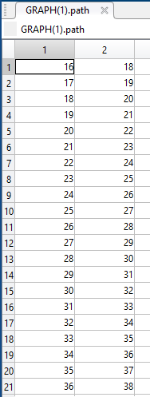
Fig. 8. Path in Graph

$$\sqrt{{\left(path_{2,1}- path_{1,1}\right)}^{2}+{\left(path_{1,2}-path_{2,2}\right)}^{2}}$$

Comparing the equation and the result from the MATLAB

$$\sqrt{\begin{aligned}{\left(GRAPH\left(1\right).path\left(2,1\right)- GRAPH\left(1\right).path\left(1,1\right)\right)}^{2}+ \\ ({\left(GRAPH\left(1\right).path\left(1,2\right)- GRAPH\left(1\right).path\left(2,2\right)\right)}^{2}\end{aligned}}$$

GRAPH(1).path(2,1) = 17
GRAPH(1).path(1,1) = 16
GRAPH(1).path(2,2) = 19
GRAPH(1).path(1,2) = 18

$$\sqrt{{\left(17-16\right)}^{2}+{\left(19-18\right)}^{2}}=1.4142$$
Since Size ( GRAPH(1).path ) = 74
$74×1.4142= 103.23$ therfore the length between node 1 and node 2 is 103.23

Then we do the same with path 2, GRAPH(2).patth
Then the length to path 3 = path from node 1 to node 2+ the path from node 2 to node 3

After we calculated the path length now we need to find the distant matrix

Open QUDARATICGRAPH
from VD.
Then open
Create matrix 26 * 26

path = GRAPH(1).path
pathnode = size(path,1);
pathlength = 0;
for i = 1: pathnode-1
temp = sqrt((path(i+1,1)-path(i,1))^2+(path(i+1,2)-path(i,2))^2);
pathlength = pathlength + temp;
end
pathlength

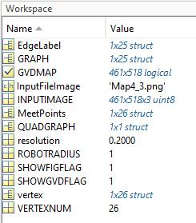

can you copy and paste theses code at the end of MainGraphMaker.m

edgesize = size(GRAPH,2);
vertexsize = size(vertex,2);
edge_M = zeros(vertexsize,vertexsize);
for j = 1 : edgesize
path = GRAPH(j).path;
pathnode = size(path,1);
pathlength = 0;
for i = 1: pathnode-1
temp = sqrt((path(i+1,1)-path(i,1))^2+(path(i+1,2)-path(i,2))^2);
pathlength = pathlength + temp;
end
x = GRAPH(j).from;
y = GRAPH(j).To;
edge_M(x,y) = pathlength;
edge_M(y,x) = pathlength;
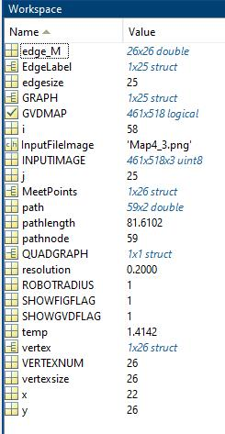

And in your workspace, edge_M is the edge matrix for the map

The Results Using Gurobi Optimizer

Meshaal Mouawad, PhD Student, Mississippi State University, Starkville, MS 39759 USA (e-mail: mm4922@msstate.edu). *

